FASD Prevention and Clinical Guidelines Research
The Uniformed Services University of the Health Sciences (USUHS) Center for Health Services Research works in collaboration with FASD United to address fetal alcohol spectrum disorders (FASD) in the Military Health System (MHS). Up to 5% of children nationally have FASD, and up to 17% of women report consuming alcohol while pregnant. Prior to the launch of the FASD Prevention and Clinical Guidelines Research project in 2022, there were no studies of FASD in the MHS, where prevalence of alcohol use is higher than the national average.
We are results-driven. To date, we have completed:
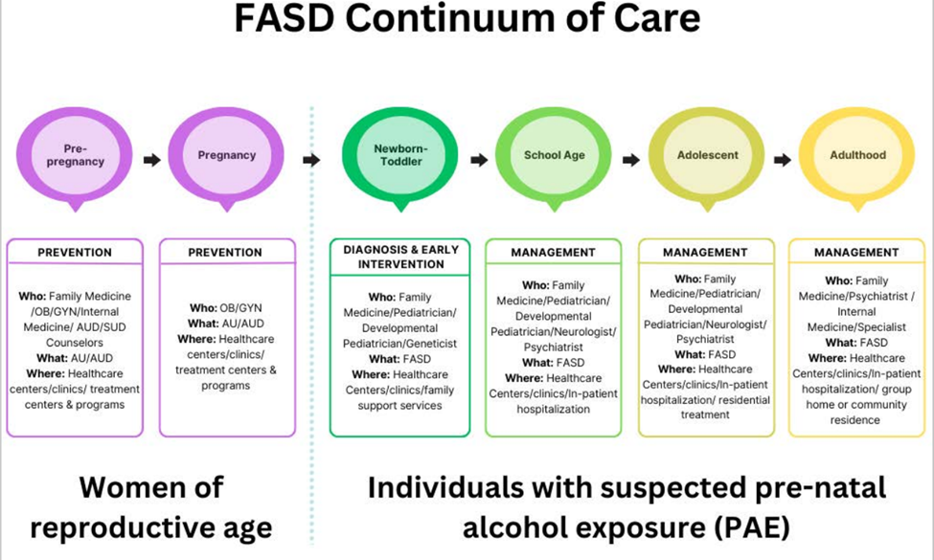
- A review of guidelines, policies, and programs on prenatal alcohol use and fetal alcohol spectrum disorders across an FASD continuum of care (Figure 1). No FASD-specific resources are available in the MHS.

Figure 1. Fetal alcohol spectrum disorders continuum of care.
- An analysis of military health claims data to identify FASD diagnoses. 1,479 children had an FASD diagnosis out of 1.7 million, which is likely a vast under-count. 2 manuscripts, 2 oral presentations planned; 1 invited talk given.
- A systematic literature review of behavioral interventions for children with neurodevelopmental disorders including FASD, with a manuscript under review.
- Standing up a partnership with Madigan Army Medical Center, home to the largest developmental pediatrics fellowship program in the MHS, to include hiring a Developmental-Behavioral Pediatrician to design and launch a telehealth program for neurodevelopmental diagnosis.
- 9-Session Tele-education Series on FASD diagnosis and management for military providers with the State of Alaska that trained over 322 providers.
- Four annual workshops that brought together program implementation experts, policy-makers, researchers, and community members with lived experience to provide feedback on program findings and inform next steps, with two resulting publications in BMC Proceedings and one forthcoming.
- Conducted a needs assessment with primary healthcare providers at military hospitals and clinics to determine knowledge of FASD in relation to prior training, as well as barriers to diagnosis and clinical management. Manuscript in review for publication.
- Received Institutional Review Board approval to stand up a pilot telehealth consult model for primary care providers that will provide consultations and education. Providers at remote clinic sites located in the Pacific Northwest (with strategic Air Force operations significance) that fall outside acceptable National Defense Authorization Act-mandated travel distances for care need support and training to diagnose neurodevelopmental disorders. This will explicitly increase access to neurodevelopmental services for families qualifying for the Exceptional Family Member Program, and is anticipated to increase the ability of EFMP families to relocate to rural bases.
Currently we are:
- Conducting a needs assessment with caregivers of military-connected children who have, or are suspected of having, FASD to understand their experiences with accessing care through the direct care system of the MHS. This assessment along with the healthcare provider assessment will be used to inform current and future projects such as the telehealth consult intervention.
- Conducting predictive analysis utilizing well-defined risk factors to identify children throughout the MHS who are at risk of having an FASD but are undiagnosed.
- Beginning the launch of our pilot telehealth consult model.
In the future we will:
- Evaluate the pilot telehealth model, to continue to determine how best to reach military-connected families and children with FASD through health care services.
- Expand and replicate the offering of digital, low-cost telehealth consults to military hospitals and clinics located across the nation and globe.
Published manuscripts:
We produce results.
- Koehlmoos, T. P., Lee, E., Rivera, I., Wisdahl, J., & Donaldson, T. (2025). Third Annual Workshop on Fetal Alcohol Spectrum Disorders Prevention and Clinical Guidelines Research: Supports, Interventions, and Therapies for the Family and Child. BMC proceedings, 19(Suppl 27), 33. https://doi.org/10.1186/s12919-025-00346-0
- Lee EH, Cirillo M, Solomon Z, Banaag A, Fuhrman B, Adams RS, Koehlmoos TP. (2025). Diagnosing prenatal alcohol exposure and fetal alcohol syndrome in military-connected children: Insights from US military data claims, 2016–2023. Alcohol Clinical & Experimental Research, 00:1-12. https://doi.org/10.1111/acer.70157
- Flake, E., Lee, E.H., Apilado, K.P., Adams, R.S., MacMahon, A. & Koehlmoos, T.P. (2025) Behavioral interventions for individuals with fetal alcohol spectrum disorder: A review of systematic reviews. Alcohol: Clinical and Experimental Research, 00, 1–12. Available from: https://doi.org/10.1111/acer.70129.
- Rivera, I., E. H. Lee, Z. Solomon and T. P. Koehlmoos (2025). "Mapping the Fetal Alcohol Spectrum Disorder Continuum of Care Across the Military Health System." Mil Med 190(3-4): 751-757. doi.org/10.1093/milmed/usae456.
- Koehlmoos, T. P., E. Lee, I. Rivera, J. Wisdahl, K. Erdman and T. Donaldson (2024). "Fetal alcohol spectrum disorders prevention and clinical guidelines research - workshop report." BMC Proc 18(Suppl 12): 15. https://doi.org/10.1186/s12919-024-00298-x.
- Koehlmoos, T. P., E. Lee, J. Wisdahl and T. Donaldson (2023). "Fetal alcohol spectrum disorders prevention and clinical guidelines research-workshop report." BMC Proceedings 17(12): 19. https://doi.org/10.1186/s12919-023-00272-z.
Manuscripts under review or in development:
Our work continues to produce results and disseminate study findings such as:
- Evaluating the Implementation of the Survey of Well-Being of Young Children at Military Bases: Perspectives from Military Health Care Providers. Under review at Military Medicine.
- Family Medicine Physicians Experiences with Fetal Alcohol Spectrum Disorders in the US Military Health System. Under review at Military Medicine.
- Identifying overlapping Autism, ADHD and other neurodevelopmental conditions among children with FASD in the MHS through claims data analysis. Under review at Military Medicine

